**Annex 4 – BMZ NARRATIVE ANNUAL REPORT**

**Christoffel-Blindenmission Deutschland e.V.**

Project Details

|  |  |
| --- | --- |
| CBM Project Number: | 4111_BMZ-MYP |
| BMZ Project Number: | 5226 |
| Project Title: | HEALTH RIGHT: Inclusive Eye and Ear and Hearing Health in Karnali of Nepal |
| City/ Country /Region: | Nepal |

|  |  |
| --- | --- |
| Name of Contractual Partner: | Nepal Netra Jyoti Sangh NNJS |

|  |  |
| --- | --- |
| Duration of Project: | 37 months |
| Project Start Date: | 1 December 2020 |
| Project End Date: | 31 December 2023 |

|  |  |
| --- | --- |
| Report Submitted by: |  |
| Name: | Man Bahadur Kunwar |
| Designation: | Project Manager |
| Email Address: | manbahadurk@nnjs.org.np |

|  |  |
| --- | --- |
| Reporting Period: | 2021/01/01 – 2021/12/31 |
| Date of Submission: | 2022/01/16 |

1. General Information
   1. **Project Short Description / Project Goal**

Karnali is one of the most underdeveloped provinces in Nepal. Basic health service for majority of population is still unavailable and not accessible because of various factors. People have little access to affordable eye and ear care which is fundamental factor influencing the prevalence of blindness and deafness. Surkhet eye hospital, located at province capital in Surkhet is only referral and treatment center for whole province. This project aims to improve the quality of life of poor population of Karnali province affected by visual and hearing impairment by ensuring affordable IEEH service through existing health system, raising awareness on prevention and treatment of eye and ear disease and enhancing professional capacities of service provider.

**Sources of Information (10 lines)**

The information for this report were taken from the following sources:

1. Monthly report
2. Quarterly report
3. Semiannual reports
4. Screening data by the community coordinators
5. Workshops/seminar reports/attendances
6. Meeting minutes
7. Eye surgical camps data
8. Financial/Financial documents
9. Field visits
10. Monitoring
11. Project documents
12. Status of Implementation of the project

*The impact matrix reflects a current-status in every bi-/annual report*

*All data should be disaggregated (women, men, girls and boys, person with disabilities, no duplications please), if possible.*

|  |
| --- |
| **Overall objective (impact):** The quality of life of the poor population of the province of Karnali affected by visual and hearing impairments is improved. |

**To reach the Overall Objective, the Project aims to reach 4 Results, each equipped with indicators:**

|  |  |  |  |  |  |
| --- | --- | --- | --- | --- | --- |
| **Specific Objective (Outcome)** | **Indicators** | | | | |
| **Target** | **Achievement only in current reporting period in numbers**  **(quantitative & qualitative)**  **2021** | **Achievement in previous reporting period in numbers**  **(As stated in previous report)** | **Total accumulated achievement up-to-date (cumulative)** | **Description of achievement so far. Explanation for over-achievement or underachievement of the indicators.** |
| Affordable quality IEEH services are part of the health system of the province of Karnali and treatment for poor people is secured. | The population practices measure to prevent eye and ear health (measured by survey). |  |  |  |  |
| 11,920 poor people have received treatment for their eye or ear disease. | Total eye(cataract) surgeries:351(180 men, 171 women)  Total Ear Surgeries:17(4 girls, 1 boy, 3 men, 9 women) |  |  | The targets could not be met due to the limited time constraints owing to the COVID Pandemic, lack of IEEH referral network services and government health facilities which are planned to upgrade to provide basic eye and ear care service under this project have not started to deliver service . facilities |
|  | An agreement for the integration of the established IEEH services into the health system of the province of Karnali has been agreed with the government and ratified in writing. Defined requirements for inclusive barrier-free services are an integral part of the agreement. | Official coordination with the local and provincial governments regarding the integration of IEEH services into the provincial health system was made. But the official agreement and ratification has not been done yet |  |  | POLICY GAP (the national and provincial health policy does not clearly mention regarding the integration of established IEEH services into the mainstream health system) |

|  |  |  |  |  |  |
| --- | --- | --- | --- | --- | --- |
| **Results** (Output) | **Indicators** | | | | |
| Target | Achievement only in current reporting period in numbers  (quantitative & qualitative)  2021 | Achievement in previous reporting period in numbers  (as stated in previous report) | Total accumulated achievement up-to-date (cumulative) | Description of achievement so far. Explanation for over-achievement or underachievement of the indicators. |
| Result 1.  The population of the 4 target districts of Jumla, Surkhet, Dailekh and Mugu is aware of measures for the prevention and treatment of eye and ear diseases as well of the IEEH services being offered. | By the end of 2023, the population has been made aware of prevention as well as eye and ear treatments and informed about integrated services through 8 street theatres, 60 murals and 8 information panels in public places, 4 school competitions, radio spots and 32 events on special holidays | * 2 school competitions conducted * 6 FM stations broadcasting jingles on eye health awareness * 6 events (3 for World Sight Day, 3 for IDDPD) organized on special holidays |  |  | The targets could not be met due to the limited time constraints owing to the COVID Pandemic.  Content/script development on eye and ear health is under process and street theatres activity will be initiated by March 2022. |
| 240 traditional healers, 320 Female Community Health Volunteers, 240 parents, were trained in the prevention and treatment of eye and ear diseases | * Traditional Healers:167(121 Men, 46 Women) * FCHVs:177(Women) * Parents: 166(55 Men, 111 Women) |  |  |  |
| 100 health workers, community and district authority representatives were trained on disability, inclusion and inclusive emergency response. | 7 Women, 19 Men (Total 26) |  |  |  |
| 16 health care facilities are barrier- free. | 16 health care facilities supported for accessibility renovation work |  |  |  |
| 4 DPOs with 100 members have strengthened their lobbying skills and are committed to inclusion and accessibility. | 16 Men with disability, 13 Men without disability, 12 women with disability, 9 women without disability (total 50) |  |  |  |
| Result 2.  In the target districts of Jumla, Mugu, Surkhet and Dailekh professional capacities and infrastructure for affordable IEEC services are permanently guaranteed. | 12 basic health stations and 4 primary health centres are equipped with ophthalmic and ear medical services in the target communities for basic care of the population. | 8 basic health stations  4 primary health centres  #4 new PEECs will be equipped with necessary medical equipments as well as furnished for accessibility modification |  |  | Eye and Ear equipments have been procured and will be equipped by February 2022 |
| 8 community coordinators and 100 community nurses working in the 16 health stations are trained in ophthalmology. They are integrated into a referral system with 2 eye clinics and 1 ENT department at the tertiary provincial hospital. | * Community coordinators: 8(2 Men, 6 Women) * Community Nurses:40 (Women without disability) |  |  |  |
| 2 eye clinics and 1 ENT department of the tertiary provincial hospital have received necessary medical equipment for further treatment and work together with health stations. 22 health workers were trained in audiology and 2 technicians in maintenance of medical equipment. | Eye Clinics:2  ENT Department: 1  Otology training: 10(9 men, 1 women) |  |  | Necessary medical equipment’s have been procured and will handed over by February 2022 |
| 126000 people participated in 128 mass screenings in schools and communities. | Total: 20829(7002 girls, 6958 boys, 3054 men, 3815 women)  Disability:192(29 girls, 40 boys, 71 men, 52 women) No of mass screenings= 480 |  |  | The targets could not be met due to the limited time constraints owing to the COVID Pandemic |
| 3,200 people were screened in 18 community screening programmes for early detection of hypertension, retinopathy and  glaucoma. | Total Screened: 402(143 men, 259 women) |  |  | The targets could not be met due to the limited time constraints owing to the COVID Pandemic |
| 5200 poor people from the communities have received cataract surgery and 320 people have received ear surgeries | Total cataract surgeries:351(180 men, 171 women) Total Ear Surgeries:17(4 girls, 1 boy, 3 men, 9 women) |  |  |  |
| Result 3. Integration of accessible IEEH services in the state health system is ensured. | In 4 lobbying meetings with representatives of the district and provincial authorities, transfer of established IEEH services to the provincial medical health system was approved and signed. | Not achieved |  |  | A provincial level eye health strategy is being drafted under the ownership of MoSD ok Karnali Province. This will address the transfer of IEEH services under the provincial health system |
| In four workshops, government representatives were given expert advice on the development and implementation of the strategy for IEEH services into government health programmes, and an MoU with an implementation plan was adopted and signed. | In 2 workshops, government representatives were trained on disability, inclusion and development through training by expert consultant |  |  | Achieved |
| In 4 lobbying meetings and 4 workshops, DPO representatives have ensured that the agreements and implementation plans take into account the inclusion of people with disabilities. | The participants of the 4 lobbying meetings and 2 workshops have verbally committed the inclusion of people with disabilities in the plans and policies |  |  | Achieved |

**2.1 Further Explanations for Changes and adaptions in initial project plan**

Though the project was designed to be implemented from December 2020, we could not start the project activities on the time due to delay in fund release and project agreement signed with CBM. The fund was received to NNJS by 3rd week of March 2021 and project agreement was signed by 2nd week of April 2021. We had planned to conduct the project inception workshop and training for eye and ear health workers by first week of April 2021. But the government announced nationwide lockdown and restrictions due to massive rise of second wave of COVID 19 pandemic. The project activities were started just by the second week of July 2021. However, there was still government restriction until September 2021. As a result all planned activities though out the year shifted to last quarter of 2021.NNJS did parallel implementation of many activities to meet the target of 2021

***a. Status of implementation of activities, in comparison to proposal***

*This is the main part of the report, where the focus is on the progress of the project implementation for the reporting year. Here we give detailed description of all implemented activities in the reporting period with photos, breakdown of target group reached per activities (women, men, girls and boys, person with disabilities, no duplications please). Hereby, we follow the structure of the proposal, describing each activity under each result.*

*If one of the results or activities have not been achieved/implemented although they were planned to be implemented in the reporting period, please describe the reason for delays, variations, challenges, obstacles and how you have or will scope them.*

**Result 1: The population of the 4 target districts of Jumla, Surkhet, Dailekh and Mugu is aware of measures for the prevention and treatment of eye and ear diseases and of the range of IEEH services.**

**1.1 Information on prevention and treatment of eye and ear diseases as well as disability and inclusion**

|  |
| --- |
| **1.1.1 Radio spots to inform people about eye and ear health** |
| Radio message on eye health awareness is being broadcasted through 6 FM/Radio stations covering the project districts since last week of December 2021 |

|  |
| --- |
| **1.1.2 Street theatre to raise awareness of eye and ear health** |
| We are coordinating with a local cultural group organization for script writing on eye, ear and blindness. Once the content is finalized, we will sign an agreement for developing and displaying the street drama in the project sites. NNJS has planned to accomplish this activity by March 2022. |

|  |
| --- |
| **1.1.3 Design and production of information material** |
| A - 2 days’ workshop was conducted at Birendranagar, Surkhet for discussing regarding the design and production of IEC material on eye and ear health dated 18 – 19 November 2021. The workshop was held among the key participants from ENT Department of Karnali Province Hospital, Surkhet Eye Hospital, Project Staff and DPO members.  250 leaflets on eye, 500 posters on ear and 500 posters on eye health awareness were designed, developed, printed and handed over to 8 community coordinators for public dissemination and distribution. We will print the IEC materials in accessible formats after conducting a workshop in March 2022. |

|  |
| --- |
| **1.1.4 Wall paintings in central places in communities** |
| We could not complete this activity due to the time constraints owing to the COVID Pandemic since there was restriction on mobility in the communities. This will be accomplished by February 2022. |

|  |
| --- |
| **1.1.5 Video spot production** |
| Script/content writing for video spot production is under process. Video spot on eye and ear health will be produced and disseminated by March 2022. |

|  |
| --- |
| **1.1.6 Production of information boards for schools and public places** |
| We have developed the awareness message on eye and ear health. Awareness information will be disseminated through hoarding boards in schools and public places by February 2022. |

|  |
| --- |
| **1.1.7 Competition on health practices** |
| On 3 December 2021, 30th IDPD was celebrated in Dullu of Dailekh district by organizing a quiz competition among 13 children with visual impairment studying in Nepal Rastriya Secondary School as part of inclusive education. The BMZ project supported for the prize distribution to those children who were provided with warm clothes for the winter. |

**1.2 Mobilization and capacity development in the communities**

|  |
| --- |
| **1.2.1 Training community coordinators (Eye and Ear Health Worker)** |
| 8 community coordinators( 2 Men, 6 Women) working in project sites from Surkhet, Dailekh, Jumla and Mugu districts of Karnali Province were trained on eye, ear and different type of disability for 6 days in an residential training program in July 2021.After being trained, they have been regularly screening and raising awareness for eye and ear problems in communities and schools. |

|  |
| --- |
| **1.2.2 Training of Female Community Health Volunteers (FCHV)** |
| As part of Community Mobilization on eye and ear health 177 Female Community Health Volunteers working in the project sites have been trained on eye and ear health. They will further disseminate knowledge on eye and ear health to community and refer client to health facilities/eye care center. |

|  |
| --- |
| **1.2.3 Training of traditional healers** |
| 167 traditional healers (121 Men, 46 women) from project sites in Dailekh and Mugu have been oriented on eye and ear health. The main objective of this training was to provide basic knowledge on eye and ear health to them to avoid any malpractices by the traditional healers against eye and ear problems among the community people. |

|  |
| --- |
| **1.2.4 Training for parents on eye and ear health** |
| 166 parents (55 Men, 111 Women) of the school children from project sites in Dailekh, Jumla and Mugu have been oriented on eye and ear health. The training will sensitize them on eye and ear health to timely seek medical services for their children. |

|  |
| --- |
| * + 1. **Capacity development of community nurses on eye and ear diseases and rehabilitation** |
| A total of 40 Community Nurses from Sinja Rural Municipality and Chandannath Municiplaity from Jumla, Gurvakot Municipality and Barahatal Rural Municiplaity from Surkhet were oriented on eye, ear and rehabilitation during the 3 days’ training programs. Once their health facilities are provided with basic eye and ear equipments, the trained nurse will start providig basic eye and ear service from their health facilites and refer serious cases to base hospitals.  facilities and |

|  |
| --- |
| **1.2.6 Training of health personnel on emergency response measures** |
| 26 state health personnel (7 women, 19 men) working in primary health facilities in project sites from Dailekh and Surkhet were trained on Disability Inclusive Disaster Risk Reduction (DiDRR) measures in a 3 days workshop in Birendranagar, Surkhet in December 2021. The main purpose of this training was to enhance knowledge and awareness of the state health personnel about vulnerability of person with disabilities during emergency situations. The participants were also trained regarding the inclusive community emergency plans. |

|  |
| --- |
| **1.2.7 Training in Disability and Inclusion**  **Further training of health personnel on emergency response measures** |
| Two workshops (each for 3 days) were organized in Birendranagar, Surkhet to train 50 DPO members (29 men, 21 women) about disability inclusion development in December 2021. There were 28 participants with different disabilities (16 men, 12 women) and there was provision for sign language interpreter for the persons with hearing disability. The participants were from project sites in Surkhet and Dailekh districts.  In a 3-day training course, the key issues "Disability inclusion into the mainstream health system" and "Development framework" were communicated to representatives of the DPOs. Blindness, visual impairment, deafness, and hearing impairment are the most common disabilities in the project areas. The DPOs members were trained to lobby for the consideration of the needs and requirements of people with disabilities at community and district level. After the training,they are to lobby for the consideration of people with disabilities in health programmes at meetings with government authorities. |

**Result 2: Result 2: In the target districts of Jumla, Mugu, Surkhet and Dailekh the professional capacities and infrastructure for affordable IEEH services are permanently guaranteed.**

**2.1 Building inclusive eye and ear health services**

|  |
| --- |
| **2.1.1 Regular screening in communities and schools** |
| A total of 20829 screenings (7002 girls, 6958 boys, 3054 men, 3815 women) were done for detection of eye and ear problems at schools and communities by 8 community coordinators in 2021. A total of 866 people (128 girls, 85 boys, 257 men, 396 women) were referred for their eye problems and 263 people (82 girls, 104 boys, 40 men, 37 women) were referred for their ear problems. There were 192 people with disabilities (29 girl, 40 boys, 71 men, 52 women) among screened population. |

|  |
| --- |
| **2.1.2 Early detection in mass screening** |
| A total of 2 comprehensive eye camps were conducted at Guthu and Bijaura of Surkhet district for early detection of glaucoma, diabetes and hypertensive retinopathies targeting at high risks groups of populations. Altogether, 402 people were screened, among which, 217 people (128 female and 89 male) were found to be diabetic. There were 15 people found to be glaucoma suspected and 3 people(2 men, 1 woman) with diabetic retinopathy suspected. The suspected cases referred to Surkhet Eye Hospital and Province Hospital for further investigation and treatement. |

|  |
| --- |
| **2.1.3 Special Public celebration days** |
| World Sight Day (WSD) is an important global event, celebrated on Thursday of second week of October all over the world to generate advocacy on eye health. This year, the day fall on 14th of October, during festival period in Nepal. So this day celebrated before and after festival. WSD celebrated in Chhayanath (Mugu) on 4th October, Chandannath (Jumla) on 5th October and Birendranagar (Surkhet) on 24th October. This was celebrated among 67 participants altogether comprising of Government officials and local geovernment representatives, DPOs, project partners and staff.  The 30th IDPD was observed in Karnali on 3 December 2021 by organizing and participating in the following events:  **1.** **Preparatory Meeting:** An interaction meeting was held among key stakeholders including Ministry of Social Development, DPOs and INF on 30th November regarding the celebration of the IDPD. The meeting decided to celebrate the event with mutual participation and contribution by all the stakeholders.  **2.** **Sports Competition among Children with Deafness:** On 2 December 2021, 72 school children with deafness participated in various sports competition in Siddha Deaf School in Birendranagar, Surkhet. The event was jointly organized with other stakeholders working in the field of disability inclusion and development. At the end of program, all participants (72) were provided stationeries with the support from BMZ project.  **3. Interaction on Women with Disabilities:** On 2 December 2021, a formal interaction program was organized to discuss the issues of women with disabilities. The event was conducted among 60 participants from DPOs, MoSD, Birendranagar Municipalities and NNJS Project staff. The event was formally chaired and opened by Deputy Mayer of Birendranagar Municiplaity, Surkhet. The speakers and presenters in the program strongly raised the problems, challenges and issues faced by the women with disabilities and urged for collective and collaborative approaches to better address the issues.  **4. Awareness Rally:** A mass awareness rally involving DPOs and allied stakeholders was organized with banners on 3 December 2021 with active and visible participation from NNJS |

**2.2 Building integrated eye and ear health services**

|  |
| --- |
| **2.2.1 Baseline study on ear and hearing care** |
| This activity has been carried forward to be executed in 2022 with official coordination with CBM. We are working on developing ToR and Expression of Interest guidelines for implementing the **Baseline study on ear and hearing care in Karnali Province.** |

|  |
| --- |
| **2.2.2 Equipment of the state basic health stations** |
| The following equipments have been procured for 8 government basic health facilities and planned to be handed over by February 2022.   |  |  |  |  | | --- | --- | --- | --- | | **SN** | **Activity Name** | **Name** | **No** | | 1 | Equipments for government Basic Health Facilities | Otoscope | 8 | | 2 | Tuning Fork | 8 | | 3 | Head Mirror | 8 | | 4 | Vision Chart | 16 | | 5 | Pinhole | 8 | |

|  |
| --- |
| **2.2.3 Establishment of an integrated eye and ear health service in Primary Health Centres** |
| |  |  | | --- | --- | | Name of Equipments | Quantity | |  | | Slit lamp Biomicroscopes | 4 |  | | Retinoscope | 4 |  | | Ophthalmoscope | 4 |  | | Trial Set | 4 |  | | Vision Drum | 4 |  | | Minor surgery sets | 4 |  | | Grinding machine for optical | 4 |  | | Backup source for electricity | 4 |  |   The following equipments have been procured under the financial support from BMZ for 4 new primary eye centres and planned to hand over by February 2022. |

|  |
| --- |
| * + 1. **Upgrade of one primary health center to an eye clinic**     2. **2.1.2 Early detection in mass screening Building up an eye clinic** |
| The following equipments have been procured under the financial support from BMZ for upgradation of surgical eye centre and will hand over by February 2022:   |  |  | | --- | --- | | Name of Equipments | Quantity | |  | | Surgical Microscope | 1 |  | | Portable biometry | 1 |  | | OT table | 2 |  | | Bed | 20 |  | | Auto clave | 1 |  | | Instruments | 10 |  | | RL stand | 2 |  | | Assist Table | 2 |  | |

|  |
| --- |
| * + 1. **Establishment of a low vision department at Surkhet Eye Hospital** |
| The following equipments have been procured under the financial support from BMZ for establishing a low vision clinic at SEH and will hand over by February 2022:   |  |  |  | | --- | --- | --- | | **S.N.** | **Devices For Low Vision Clinic at SEH** | **No** | | **1** | Streak retinoscope | 1 | | **2** | Direct ophthalmoscope | 1 | | **3** | Trial lens set (full aperture) | 1 | | **4** | Universal trial frames | 1 | | **5** | Pediatric trial frames (2 pairs of different sizes) | 2 | | **6** | Long handle occluder with pinholes | 2 | | **7** | Pen torch | 1 | | **8** | Distant LogMAR test charts | 3 | | **9** | Near vision tests | 4 | | **10** | Symbol pediatric tests for matching and pointing (with and without crowding) | 2 | | **11** | PV-16 Color Vision Test (double set) | 2 | | **12** | Spectacle magnifiers (half eyes) | 12 | | **13** | Foldable and hand-held magnifiers with and without built-in light source | 12 | | **14** | Stand magnifiers | 12 | | **15** | Dome and bar magnifiers | 8 | | **16** | Hand-held monocular telescopes | 8 | | **17** | Filters | 10 | | **18** | Color TV Set | 1 | | **19** | Black and white hand-held CCTV magnifier | 1 | | **20** | Full color hand-held CCTV magnifier | 1 | |

|  |
| --- |
| * + 1. **Improvement of eye health services at the Surkhet Eye Hospital** |
| The following Eye equipments have been procured under the financial support from BMZ for upgradation of ophthalmological services at SEH and planning to hand over by February 2022.   |  |  | | --- | --- | | Name of Equipments | Quantity | |  | | Humphry | 1 |  | | Slit Lamp | 1 |  | | Loose prism | 1 |  | | Kitmus Set | 1 |  | | Computerized vision drum with magic chart | 1 |  | | Pachymetry | 1 |  | | Edging machine | 1 |  | |

|  |
| --- |
| * + 1. **Strengthening the ENT department at Karnali Provincial Hospital in Surkhet** |
| The following Ear equipments have been procured under the financial support from BMZ for strengthening the ENT Department of KPH and will hand over by February 2022.   |  |  |  | | --- | --- | --- | | **S.N.** | **Name** | **No.** | | **1** | Myringoplasty set | **2** | | **2** | MRM set | **2** | | **3** | Tympanometer | **2** | | **4** | Pure Tone Audiogram (PTA) | **2** | | **5** | General ENT OPD working MRM Dril | **1** | | **6** | PTA Tympanometry unit with Audiogram | **2** | | **7** | Head Lights | **4** | | **8** | Suction machine | **3** | | **9** | Tunning Forks (256,512,1024 HZ) | **6** | | **10** | Ear OPD Instruments | **1** | | **11** | Ottoscope | **5** | | **12** | Portable Microscope | **1** | |

|  |
| --- |
| **2.2.8 Improvement of accessibility at the primary health center** |
| In 2021, accessibility audit of 16 state owned primary health centres conducted, from the project sites in Surkhet, Dailekh and Jumla. All the 16 HFs have been financially supported for their accessibility modifications as per the accessibility audit reports.The following health facilities have been audited and supported for the accesibility work:   |  |  |  | | --- | --- | --- | | S.N. | Name | Address | |  | Kunathari Health Post | Barahatal, Surkhet | |  | Lekhgaun Health Post | Barahatal, Surkhet | |  | Sahare Health Post | Gurvakot, Surkhet | |  | Dahachour Health Post | Gurvakot, Surkhet | |  | Primary Eye Care Center | Narayan Municiplaity, Dailekh | |  | Belaspur Health Post | Narayan Municiplaity, Dailekh | |  | Tribeni Health Post | Narayan Municiplaity, Dailekh | |  | Community Eye Care Center | Dullu Municipality, Dailekh | |  | Gamaudi Health Post | Dullu Municipality, Dailekh | |  | Paduka Health Post | Dullu Municipality, Dailekh | |  | Dhapa Health Post | Sinja Rural Municiplaity, Jumla | |  | Narakot Health Post | Sinja Rural Municiplaity, Jumla | |  | Sanigaun Health Post | Sinja Rural Municiplaity, Jumla | |  | Primary Eye Center | Chandannath Municipality, Jumla | |  | Talium Health Post | Chandannath Municipality, Jumla | |  | Mahat Health Post | Chandannath Municipality, Jumla | |

|  |
| --- |
| * + 1. **Cataract surgery at Surkhet Eye Hospital** |
| A total of 128 cataract surgeries of 62 Women and 66 men were performed for vision restoration at Surkhet Eye Hospital under the BMZ consumable partial support in 2021.  We could not achieve the targets of this activity mainly due to limited time constraint owing to COVID Pandemic, delay in start of the project implementation, limited capacity and multiple donors of Surkhet Eye Hospital. |

|  |
| --- |
| * + 1. **Implementation of cataract surgery campaigns in remote regions** |
| A 3 days’ eye surgical camp was organized in Dullu of Dailekh District from December 10 to 12, 2021, by NNJS Project Office through financial support from BMZ. Surkhet Eye Hospital, technical partner of this project provided support for screening and surgical interventions. Altogether 223 cataract surgeries conducted during camp amongthem 109 women and 114 men restored their vision.  Prior to the surgical camp, 2 technical teams from Surkhet Eye Hospital conducted cataract screenings for 5 days in six sites in Dullu. They examined 895 people (510 Female and 385 Male) and referred over 200 cases with cataract including other eye diseases.  During camp, a total of 223 people (109 Female, 114 male) were examined for identification and treatment of their eye conditions. |

|  |
| --- |
| * + 1. **Ear surgery campaigns** |
| A total of 17 ear surgeries (4 boys, 1 girl,3 men 9 women) were performed at Karnali Province Hospital under poor patient subsidy provision with financial consumable support from BMZ 4111 project in 2021. This target could not be achieved mainly because of delayed agreement with the Province Hospital, Corona Pandemic and comaparatively very few number of hospital visits of the surgical cases. |

* 1. **Capacity development in the state health sector**

|  |
| --- |
| **2.4.1 Training on maintenance of medical equipment**  **Workshop presentation including school clubs** |
| 1 person from Surkhet Eye Hospital and 1 person from Karnali Province Hospital will be trained on maintenance of medical equipment in March 2022. We are coordinating with training institutes in Kathmandu regarding this training. |

|  |
| --- |
| * + 1. **Audiology training of state health personnel** |
| A total of 10 state health personnel from project sites’ government basic health facilities have been trained in 2021 for basic otology at Karnali Province Hospital. The training is ongoing for basic otology.After the training, they will regularly provide primary ear care treatments and necessary referrals to the base hospitals that will be reported as the project achievement.  2 health personnel (1 from Gurvakot and 1 from Dullu) have been enrolled for basic otology training at Karnali Province Hospital since December 15, 2021 and will complete the training by 14th January 2022 |

**Result 3: The integration of integrated ophthalmic and otologic services in the public health system is ensured**

|  |
| --- |
| **3.1.1 Lobbying meeting with representatives of local, district and regional authorities** |
| 8 coordination meetings with the local and district authorities and 1 coordination meetings with the authorities from Ministry of Social Development have been conducted for discussing about the project implementation and integration of eye health in government health system.  During the meetings with the local and district authorities, they have strongly committed for necessary coordination and support for the project activities. Similarly, the provincial authorities have verbally showed their commitment for the integration of eye and ear care services into the mainstream health system. |

|  |
| --- |
| **3.1.2 Eye and ear health committee at district level** |
| A total of 8 eye and ear health committee have been formed in the project sites of 4 districts: Surkhet, Dailekh, Jumla and Mugu. The committee have been formed under the chairmanship of head of the local municipalities comprising of other members from health, education, social units and members from DPOs. Regular coordination meetings are held in every 2 months for review and feedback on project implementation at local levels. |

|  |
| --- |
| **3.1.3 Revision of the National Health Strategy** |
| A national eye health strategic plan has been drafted and formulated jointly by the Ministry of Health and Population, NNJS and other partners working in eye sector. Similarly, a task force under the Ministry of Social Development, Karnali Province is drafting a provincial level eye health strategy. Two workshops for the review and revision of these strategies will be organized by the third week of February 2022. |

|  |
| --- |
| **3.1.4 Disability Inclusive Development (DID) Training** |
| A 3 Days’ Disability Inclusion Development Seminar was organized and conducted in Birendranagar Surkhet from 21 to 23 December, 2021. There were altogether 23 participants (11 women, 12 men) from Health, Education and Social department of Gurvakot Municipality, Barahatal Rural Municiplaity of Surkhet and Dullu and Narayan Municipalities from Dailekh district, Ministry of Social Development and DPOs. There were 8 participants (4 women, 4 men) with different kind of disabilities and project provided regional accomodation as per need along with sign language interpreter for persons with hearing disabilities.  The aim was to ensure that state actors take inclusion into account when planning their programmes. For this reason, representatives of health, social and educational authorities were trained on the concept of DID together with representatives of DPOs in a 3-day seminar in Surkhet. |

**2.2 Cooperation with other actors in the reporting period (beyond project partners)**

Few interactive meetings and discussions were held with local authorities in 5 municipalities in the project districts regarding the establishment of 4 new Integrated primary eye and ear centers and 1 surgical eye center in partnership with the local government.

We officially coordinated with the local government entities since the beginning of the project implementation. Regarding the regular screening activities by our field coordinators, local leaders, ward chairman, FCHVs and government health personnel are supporting. We conducted accessibility audit of 16 government health facilities, trained 12 health personnel on basic otology in coordination and collaboration with local and provincial government. We coordinate with DPOs, schools and communities for the implementation of different project activities in our area.

**2.3 Activities planned in 2022:**

|  |  |
| --- | --- |
| **Activity No.** | **Name of Activity** |
| **R01** | **The population of the 4 target districts of Jumla, Surkhet, Dailekh and Mugu is informed about prevention, treatment options and IEEH services.** |
| A01.01 | Radio spots to inform people about eye and ear health |
| A01.02 | Street theatre to raise awareness of eye and ear health |
| A01.03 | Design and production of information material |
| A01.04 | Wall paintings in central places in communities |
| A01.05 | Video spot production |
| A01.06 | Production of information boards for schools and public places |
| A01.07 | Competition on health practices |
| A01.08 | Training of Eye and Ear Health Workers |
| A01.09 | Training of Female Community Health Volunteers (FCHV) |
| A01.10 | Training of traditional healers |
| A01.11 | Training for parents on eye and ear health |
| A01.12 | Capacity development of community nurses on eye and ear diseases and rehabilitation |
| A01.13 | Training of health personnel on emergency response measures |
| A01.14 | Training in Disability and Inclusion |
| **R02** | **In the target districts of Jumla, Mugu, Surkhet and Dailekh the professional capacities and infrastructure for affordable IEEH services are permanently guaranteed.** |
| A02.01 | Regular screening in communities and schools |
| A02.02 | Early detection in mass screening |
| A02.03 | Special Public Celebration Day |
| A02.04 | Baseline study on ear and hearing care |
| A02.05 | Equipment of Basic Health Stations |
| A02.06 | Establishment an integrated eye and ear health service in Primary Health Centres |
| A02.07 | Upgrade of one Primary Health Centre to an Eye Clinic |
| A02.08 | Establishment of a Low Vision Department at Surkhet Eye Hospital |
| A02.09 | Improvement of Eye Health Services at Surkhet Eye Hospital |
| A02.10 | Strengthening the ENT department at Karnali Provincial Hospital in Surkhet |
| A02.12 | Cataract surgery at Surkhet Eye Hospital |
| A02.13 | Implementation of cataract surgery campaigns in remote regions |
| A02.14 | Ear surgery campaigns |
| A02.15 | Training on maintenance of medical equipment |
| A02.16 | Audiology training of state health personnel |
| **R03** | **The inclusion of integrated ophthalmic and otologic services within public health system is ensured** |
| A03.01 | Lobbying meeting with representatives of local, district and regional authorities |
| A03.02 | Eye and Ear Health Committee at district level |
| A03.03 | Revision of the National Health Strategy |
| A03.04 | Disability Inclusive Development (DID) Training |

1. Findings of the Project (Challenges and Lessons learned)

Please complete the table below with challenges that were encountered during the reporting period and the lessons learned. Include any solution that you plan to implement in the next reporting period. (If you have used the Status Column in the Indicator Tracking Sheet (Column K) to report Challenges against specific indicators, make sure you elaborate on the challenge in the table below.)

|  |  |
| --- | --- |
| **Challenge** | **Lessons Learned / solutions** |
| Time constraint owing to COVID Pandemics in 2021 | We accomplished most of the project activities through parallel planning and implementation |
| Hospital based cataract surgeries could not be met due to limited capacity of Surkhet Eye Hospital, multiple donors’ engagement  et the targets | These targets can be met through implementation of eye surgical campaigns, involving other technical partners in coordination with CBM Global, Country Office, Nepal |
| Delayed start of the project implementation led to the limited time constraints | We accomplished most of the project activities through parallel planning and execution |
| Referred cases of eye and ear surgeries hardly comes to hospital due to high opportunity cost | Comprehensive eye and ear surgical campaigns can be planned to address the financial and geographical barriers |
| Outreach activities cannot be done throughout the whole year due to climatic extremities | Seasonal pro-active planning should be done to conduct these activities based on the local circumstance |

1. Risk Update

|  |  |  |
| --- | --- | --- |
| **Risk** | **Effects** | **Mitigation Strategies** |
| COVID Pandemic | Limited time constraint for the implementation of most of project activities | Proactive planning and parallel execution of the activities |
| Multiple donors of Surkhet Eye Hospital | Interfered to meet the targets of hospital based and camp cataract surgeries | Involvement of other eye technical partners in coordination with CBM Country office |
| Limited technical HR capacity of Surkhet Eye Hospital | Limited the execution of cataract surgical camps and hospital-based cataract surgeries | Coordinating with CBM Country Office to go for best alternatives |
| Snowfall in Jumla and Mugu | Interference in conducting regular eye, ear screening and conducting surgical camps in Winter | Mass screening need to plan efficiently from march to October |
| Upcoming election, change of mind of political leaders’ commitment | Delay of establishment of eye and ear care centres | More emphasis on lobbying with bureaucrats together with the local government representatives |

1. Other remarks

*N/A*

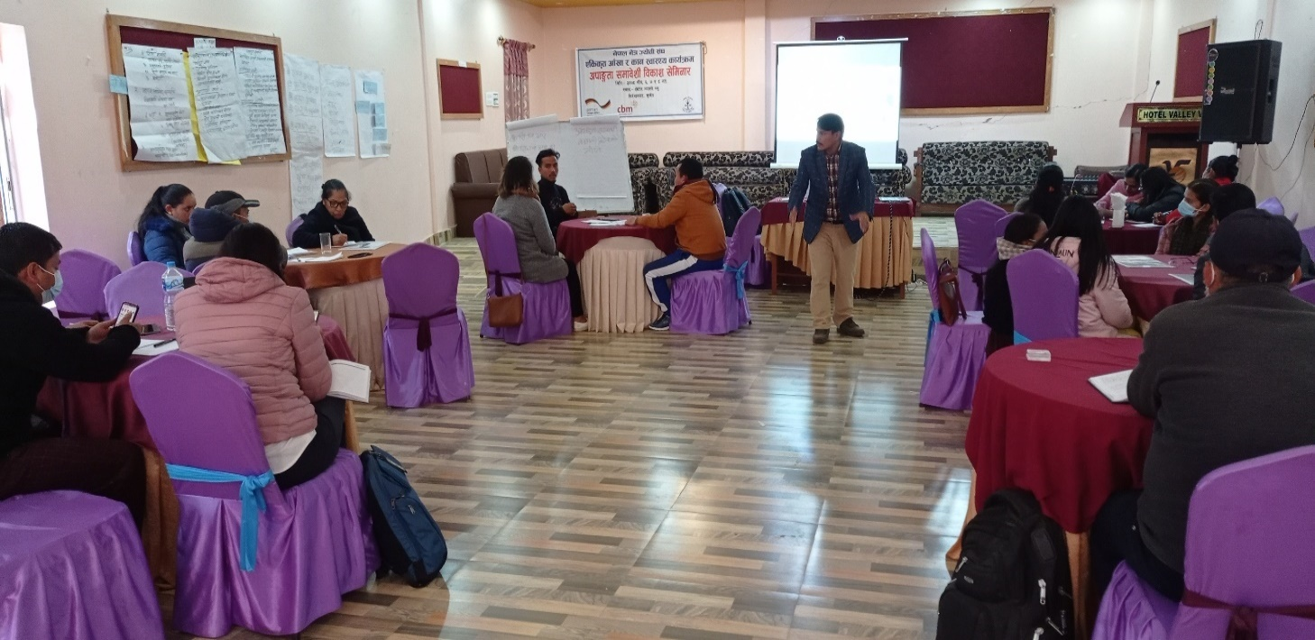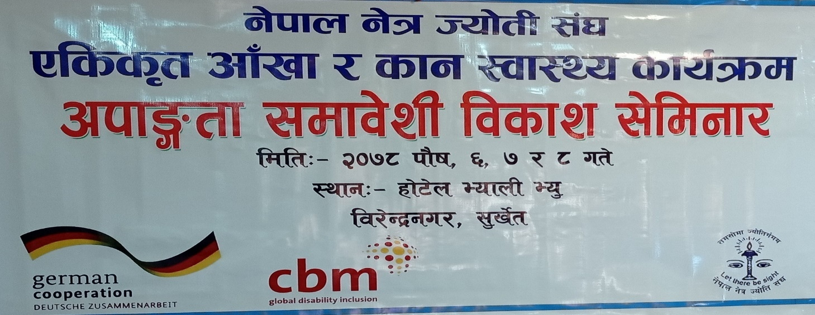***4 Photos***

**Participants attending DID Seminar at Surkhet**

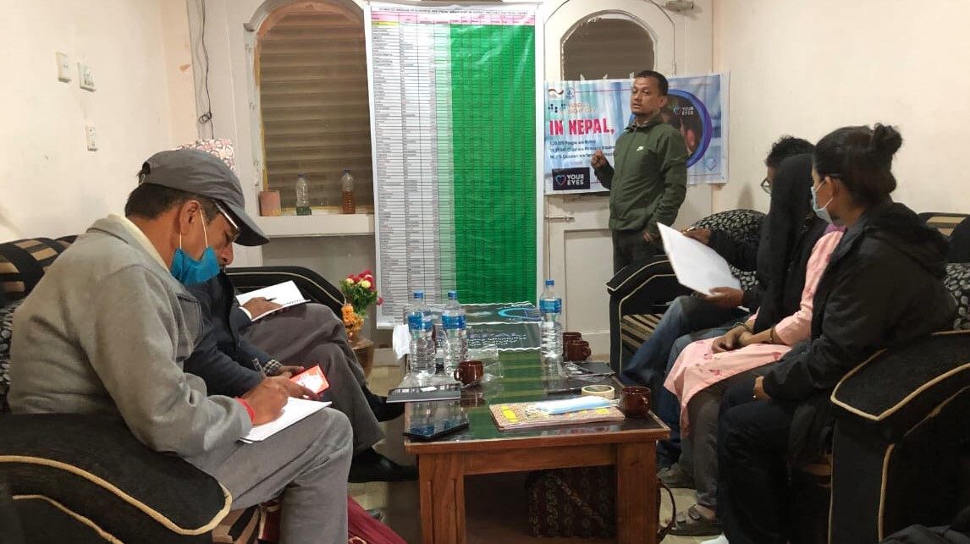

**World Sight Day Celebration in Mugu**

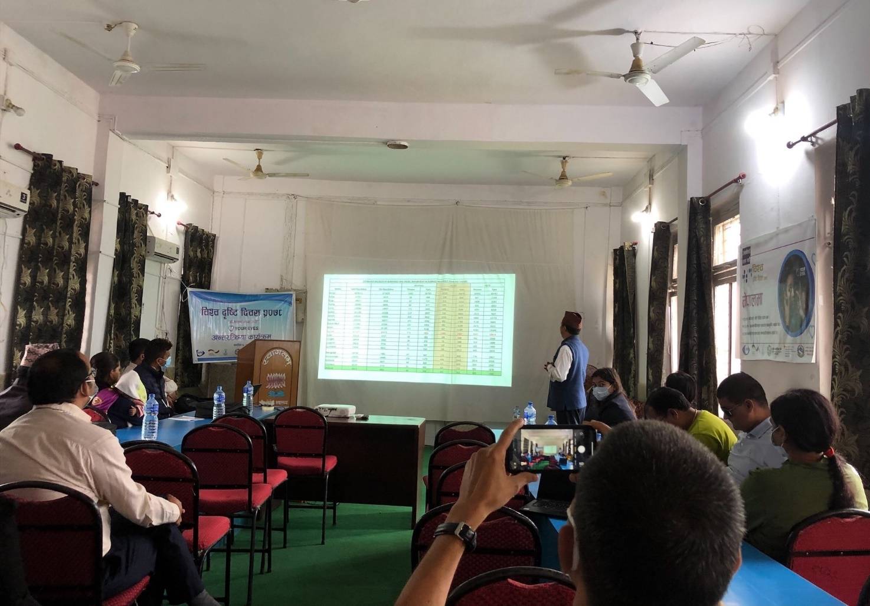

**World Sight Day Celebration in Surkhet**

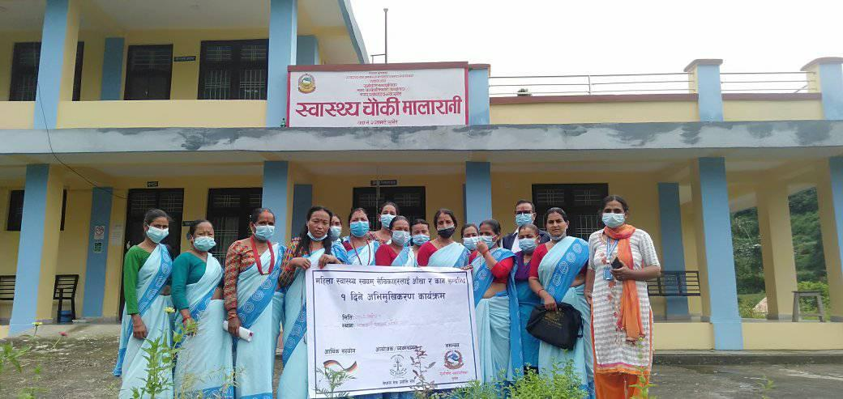

**FCHVs Orientation at Gurvakot, Surkhet**

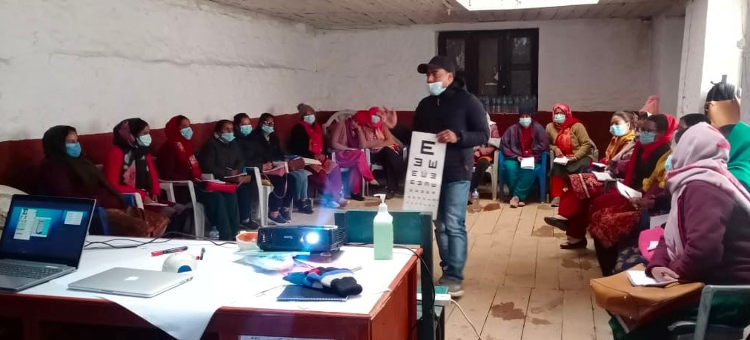

**Training of Community Nurses in Jumla**

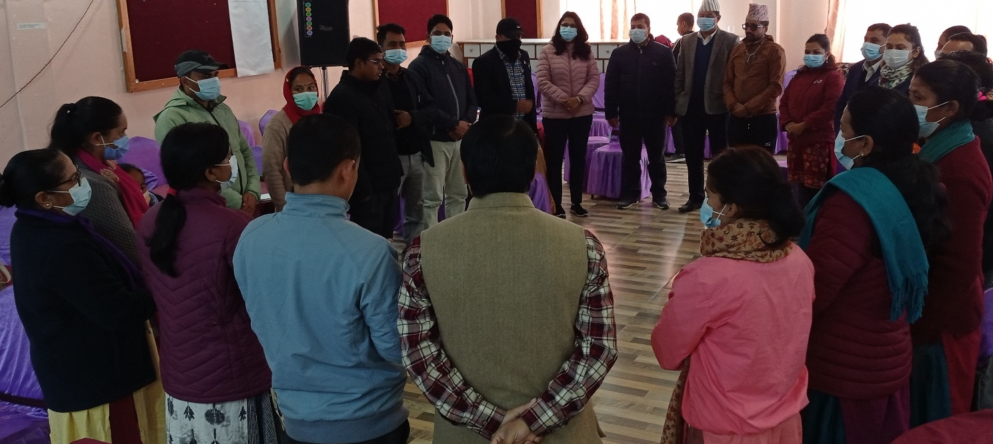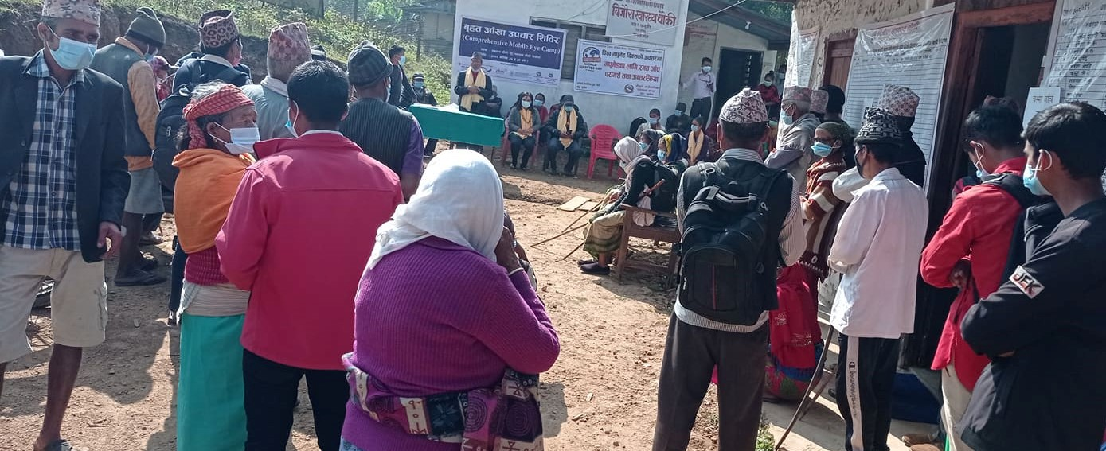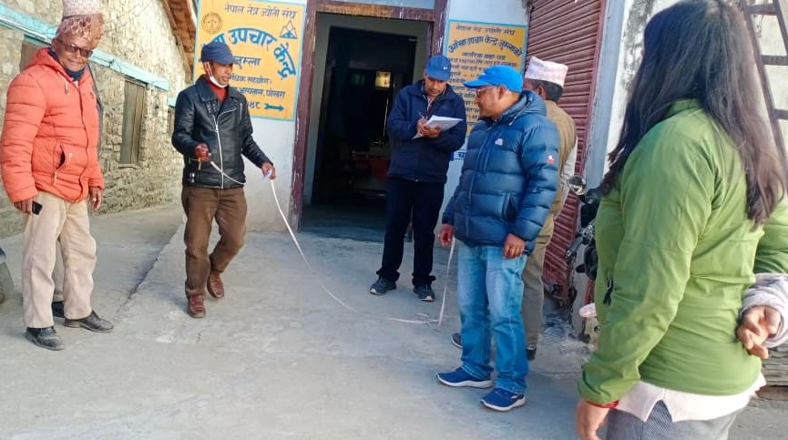

**Participants attending for DID Training in Surkhet**

**Mass screening for early detection of glaucoma, diabetic retinopathy at Chaukune in Surkhet**

**Accessibility audit of a primary eye care centre being conducted in Jumla**

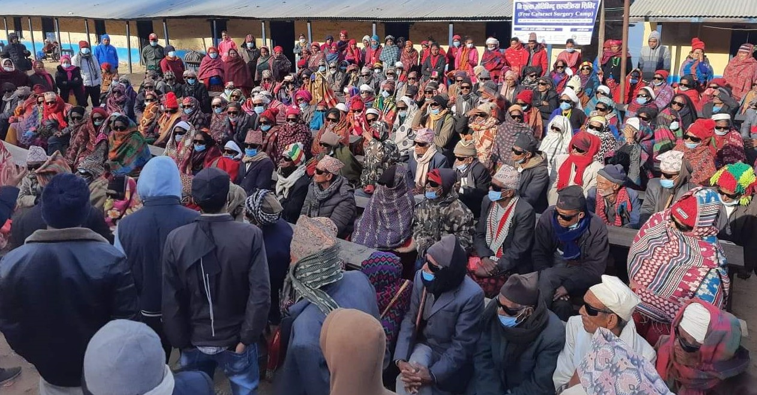

**Cataract surgical camp at Dullu, Dailekh**

**Success Story : A One-Eyed Women from a remote village Restores her Normal Vision**

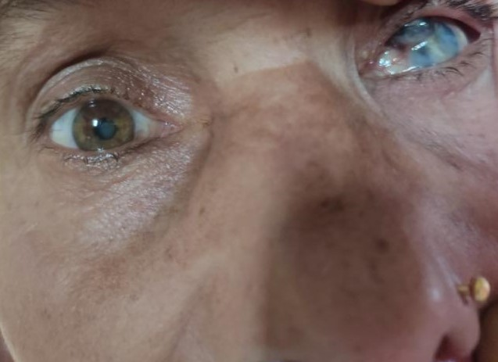Dil Maya Singh, 62 years old woman, lives at Pauwa Tole – 8, Dullu Municipality, Dailekh district. She is accompanied at her home by her husband, 2 sons, 1 daughter in law, 1 daughter and 2 grandchildren. Her low middle-class family heavily lives on farming and livestock. One day, seven years ago, she completely lost her vision in her left eye after traumatized by the horn of her domestic bull with only her right eye remaining for her sight and livelihood. Unfortunately, she underwent continuous deterioration of vision in her only remaining eye for last two years. She was desperate and disappointed with her life because she could not carry out her daily tasks that she could have done previously. She did not even try to seek treatment because of her previous bitter experience that she could not recover vision in the **Before Surgery**

traumatic eye despite her visit to eye hospital.

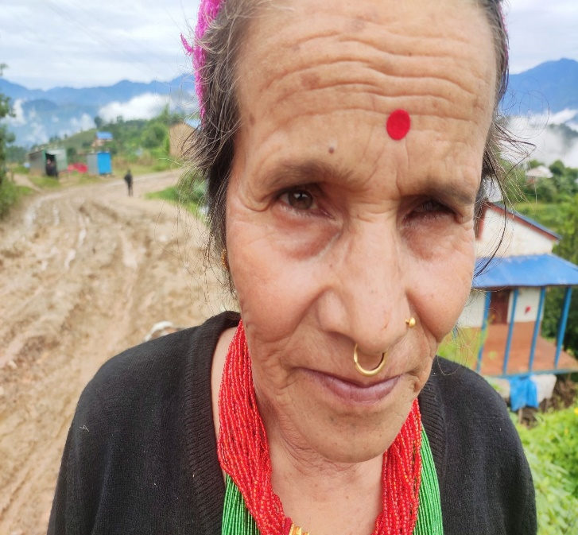She was a missed opportunity for our Field Coordinator, Sima Kumari Shahi when she assessed her vision in regular community screening activity and found her vision in left eye completely blind and her right eye could see hardly at a distance of 3 meters (3/60) falling in the severe vision impairment category due to cataract. This time, she determined to go to Surkhet Eye Hospital after counselling and motivation by our Field Coordinator and finally she restored her good visual outcome in her left eye (6/9) after cataract surgery under BMZ consumable support. She now can carry out her daily **After Surgery**

tasks independently and grateful to all persons and organizations who helped and motivated for her new brightful life.

5 Comments from responsible CBM Office

BMZ project is in first year of implementation. Though project officially started from December, its implementation in community level started form July, 2021 only. This project has affected by second wave of covid pandemic in Nepal. However, NNJS has given their best effort to carry out key intervention in 2021. There was big procurement under this project in 2021, which demanded through process and compliance. Most of this equipment had to shipped from abroad. They have procured all planned equipment in 2021 however its handover to respective health facilities have not done. This is one of the major reasons for underachievement of target related to service delivery. Similarly, achievement for cataract surgery is too low. CBM CO is planning to have joint meeting with NNJs and Surkhet eye hospital who is the technical partner of this project. We expect that meeting will come up with contingency plan to catch up the target.

Nevertheless, NNJS has put their full effort to implement most of the activity planned for 2021. Some activities along with budget (100K Euro) of 2021 are shifted to 2022 with communication and approval from CBM Germany who is the main point of contact for this project. Similarly, underspent in HR and Admin has been reutilized to provide additional equipment support to Karnali Province hospital based on their request with the approval from BMZ.

CBM Nepal country office carried out one physical monitoring visit of project in 2021. It was visit of eye care center in one of the project sites of Surkhet district where NNJs had proposed for clinical service upgradation. However, CBM NCO has been providing support to NNJS/project team virtually in smooth and quality project implementation. s